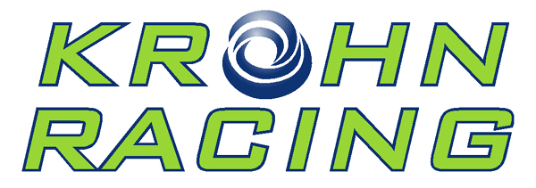
2011 Results:
ROLEX 24 AT DAYTONA - Grand-Am
January 29-30, 2011
Daytona International Speedway
Daytona Beach, Florida
No. 75 - Started 15th - Finished 6th in class - 6th overall
_______________________________________
12 HOURS OF SEBRING - ILMC/ALMS
March 19, 2011
Sebring International Raceway
Sebring, Florida
No. 57 - Started 2nd in class - Finished 1st in class, 19th overall
6 HOURS OF Spa - ILMC
May 7, 2011
Spa-Francorchamps
Spa, Belgium
No. 57 - Started 10th in class - Finished 8th in class, 32nd overall
24 Hours of Le Mans - ILMC/ACO
June 11-12, 2011
Circuit de la Sarthe
Le Mans, France
No. 57 - Started 7th in class - Finished DNF
6 HOURS OF Imola - ILMC
July 3, 2011
Enzo and Dino Ferrari Circuit
Imola, Italy
No. 57 - Started 3rd in class - Finished 7th in class, 38th overall
6 HOURS OF Silverstone - ILMC
September 13, 2011
Silverstone Circuit
Milton Keynes, UK
No. 57 - Started 4th in class - Finished 7th in class, 39th overall

Petit Le Mans - ILMC/ALMS
October 1, 2011
Road Atlanta
Braselton, GA USA
No. 57 - Started 2nd in GTE-AM class - Finished 1st in class, 24th overall
6 HOURS of Zhuhai - ILMC
November 13, 2011
Zhuhai International Circuit
Zhuhai, China
No. 57 - Started 3rd in class - Finished 3rd in class, 14th overall

